Forecasting model

##importing the data set

sales <- read.csv(file.choose())

str(sales)

## in th edata set we have two variable one is month and one is sales

## We will change the number of months into dummy variable

X<- data.frame(outer(rep(month.abb,length = 60), month.abb,"==") + 0 )# Creating dummies for 12 months

View(X)

colnames(X)<-month.abb # Assigning month names

View(X)

##combining the x to the data

newsales <- cbind(sales,X)

newsales <- newsales[,-1]

newsales['t'] <- 1:60

View(newsales)

newsales['log_sales'] <- log(newsales$Sales)

View(newsales)

newsales['t_squared'] <- newsales$t*newsales$t

View(newsales)

attach(newsales)

##spliting the data##

train <- newsales[1:45,]

test <- newsales[45:60,]

########################### LINEAR MODEL #############################

linear_model<-lm(Sales~t,data=train)

summary(linear_model)

linear_pred<-data.frame(predict(linear_model,interval='predict',newdata =test))

View(linear_pred)

rmse_linear<-sqrt(mean((test$Sales-linear_pred$fit)^2,na.rm = T))

rmse_linear # 243.6692

######################### Exponential #################################

expo_model<-lm(log_sales~t,data=train)

summary(expo_model)

expo_pred<-data.frame(predict(expo_model,interval='predict',newdata=test))

rmse_expo<-sqrt(mean((test$log_sales-exp(expo_pred$fit))^2,na.rm = T))

rmse_expo # 1409.767

######################### Quadratic ####################################

Quad_model<-lm(Sales~t+t_squared,data=train)

summary(Quad_model)

Quad_pred<-data.frame(predict(Quad_model,interval='predict',newdata=test))

rmse_Quad<-sqrt(mean((test$Sales-Quad_pred$fit)^2,na.rm=T))

rmse_Quad # 274.362

######################### Additive Seasonality #########################

sea_add_model<-lm(Sales~Jan+Feb+Mar+Apr+May+Jun+Jul+Aug+Sep+Oct+Nov,data=train)

summary(sea_add_model)

sea_add_pred<-data.frame(predict(sea_add_model,newdata=test,interval='predict'))

rmse_sea_add<-sqrt(mean((test$Sales-sea_add_pred$fit)^2,na.rm = T))

rmse_sea_add # 253.816

######################## Additive Seasonality with Linear #################

Add_sea_Linear_model<-lm(Sales~t+Jan+Feb+Mar+Apr+May+Jun+Jul+Aug+Sep+Oct+Nov,data=train)

summary(Add_sea_Linear_model)

Add_sea_Linear_pred<-data.frame(predict(Add_sea_Linear_model,interval='predict',newdata=test))

rmse_Add_sea_Linear<-sqrt(mean((test$Sales-Add_sea_Linear_pred$fit)^2,na.rm=T))

rmse_Add_sea_Linear #114.235

######################## Additive Seasonality with Quadratic #################

Add_sea_Quad_model<-lm(Sales~t+t_squared+Jan+Feb+Mar+Apr+May+Jun+Jul+Aug+Sep+Oct+Nov,data=train)

summary(Add_sea_Quad_model)

Add_sea_Quad_pred<-data.frame(predict(Add_sea_Quad_model,interval='predict',newdata=test))

rmse_Add_sea_Quad<-sqrt(mean((test$Sales-Add_sea_Quad_pred$fit)^2,na.rm=T))

rmse_Add_sea_Quad # 146.5779

######################## Multiplicative Seasonality #########################

multi_sea_model<-lm(log_sales~Jan+Feb+Mar+Apr+May+Jun+Jul+Aug+Sep+Oct+Nov,data = train)

summary(multi_sea_model)

multi_sea_pred<-data.frame(predict(multi_sea_model,newdata=test,interval='predict'))

rmse_multi_sea<-sqrt(mean((test$Sales-exp(multi_sea_pred$fit))^2,na.rm = T))

rmse_multi_sea # 258.3827

######################## Multiplicative Seasonality Linear trend ##########################

multi_add_sea_model<-lm(log_sales~t+Jan+Feb+Mar+Apr+May+Jun+Jul+Aug+Sep+Oct+Nov,data = train)

summary(multi_add_sea_model)

multi_add_sea_pred<-data.frame(predict(multi_add_sea_model,newdata=test,interval='predict'))

rmse_multi_add_sea<-sqrt(mean((test$Sales-exp(multi_add_sea_pred$fit))^2,na.rm = T))

rmse_multi_add_sea # 129.1332

# Preparing table on model and it's RMSE values

table_rmse<-data.frame(c("rmse_linear","rmse_expo","rmse_Quad","rmse_sea_add","rmse_Add_sea_Linear","rmse_Add_sea_Quad","rmse_multi_sea","rmse_multi_add_sea"),c(rmse_linear,rmse_expo,rmse_Quad,rmse_sea_add,rmse_Add_sea_Linear,rmse_Add_sea_Quad,rmse_multi_sea,rmse_multi_add_sea))

View(table_rmse)

colnames(table_rmse)<-c("model","RMSE")

View(table_rmse)

#Addictive seasonality linear trend has least RMSE value

new_model <- lm(Sales~t+Jan+Feb+Mar+Apr+May+Jun+Jul+Aug+Sep+Oct+Nov,data = newsales)

# Building Autoregressive model on residuals consider lag-1

resid <- residuals(new_model)

resid[1:10]

windows()

acf(resid,lag.max = 10)

# By principal of parcimony we will consider lag - 1 as we have so

# many significant lags

k <- arima(resid, order=c(1,0,0))

str(k)

View(data.frame(res=resid,newresid=k$residuals))

windows()

acf(k$residuals,lag.max = 15)

pred_res<- predict(arima(k$residuals,order=c(1,0,0)),n.ahead = 12)

str(pred_res)

pred_res$pred

acf(k$residuals)

|  |  |  |
| --- | --- | --- |
| **1** | rmse_linear | 243.6692 |
| **2** | rmse_expo | 1409.7670 |
| **3** | rmse_Quad | 274.3620 |
| **4** | rmse_sea_add | 253.8168 |
| **5** | rmse_Add_sea_Linear | 114.2350 |
| **6** | rmse_Add_sea_Quad | 146.5779 |
| **7** | rmse_multi_sea | 258.3827 |
| **8** | rmse_multi_add_sea | 129.1332 |

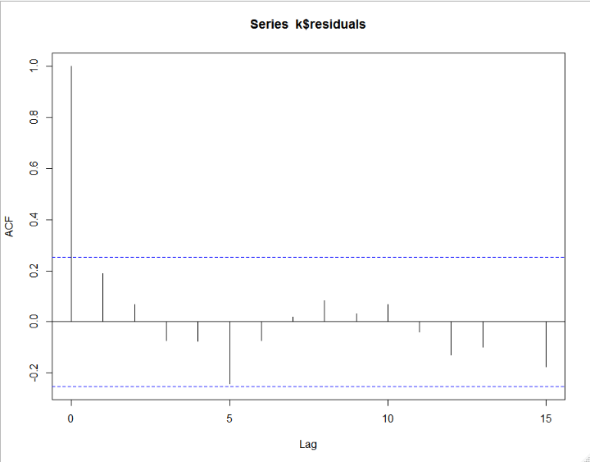

Data set Coca-Cola

library(readxl)

#loading the data in excel into the system##

data <- read_excel(file.choose())

View(data)## quarter seasonality in the dataset##

head(data)

windows()

attach(data)

plot(data$Sales,type='o')

##creating four dummy variable because four quarters##

Q1 <- ifelse(grepl("Q1",data$Quarter),'1','0')

Q2 <- ifelse(grepl("Q2",data$Quarter),'1','0')

Q3 <- ifelse(grepl("Q3",data$Quarter),'1','0')

Q4 <- ifelse(grepl("Q4",data$Quarter),'1','0')

##combining the dummy variable with the data##

data <- cbind(data,Q1,Q2,Q3,Q4)

colnames(data)

data['t'] <- 1:42

View(data)

data["log_Sales"]<-log(data["Sales"])

data["t_square"]<-data["t"]*data["t"]

attach(data)

View(data)

train<-data[1:36,]

test<-data[36:42,]

########################### LINEAR MODEL #############################

linear_model<-lm(Sales~t,data=train)

summary(linear_model)

linear_pred<-data.frame(predict(linear_model,interval='predict',newdata =test))

View(linear_pred)

rmse_linear<-sqrt(mean((test$Sales-linear_pred$fit)^2,na.rm = T))

rmse_linear # 620.7862

######################### Exponential #################################

expo_model<-lm(log_Sales~t,data=train)

summary(expo_model)

expo_pred<-data.frame(predict(expo_model,interval='predict',newdata=test))

rmse_expo<-sqrt(mean((test$log_Sales-exp(expo_pred$fit))^2,na.rm = T))

rmse_expo # 4238.53

######################### Quadratic ####################################

Quad_model<-lm(Sales~t+t_square,data=train)

summary(Quad_model)

Quad_pred<-data.frame(predict(Quad_model,interval='predict',newdata=test))

rmse_Quad<-sqrt(mean((test$Sales-Quad_pred$fit)^2,na.rm=T))

rmse_Quad # 458.8969

######################### Additive Seasonality #########################

sea_add_model<-lm(Sales~Q1+Q2+Q3+Q4,data=train)

summary(sea_add_model)

sea_add_pred<-data.frame(predict(sea_add_model,newdata=test,interval='predict'))

rmse_sea_add<-sqrt(mean((test$Sales-sea_add_pred$fit)^2,na.rm = T))

rmse_sea_add # 1822.849

######################## Additive Seasonality with Linear #################

Add_sea_Linear_model<-lm(Sales~t+Q1+Q2+Q3+Q4,data=train)

summary(Add_sea_Linear_model)

Add_sea_Linear_pred<-data.frame(predict(Add_sea_Linear_model,interval='predict',newdata=test))

rmse_Add_sea_Linear<-sqrt(mean((test$Sales-Add_sea_Linear_pred$fit)^2,na.rm=T))

rmse_Add_sea_Linear #525.0682

######################## Additive Seasonality with Quadratic #################

Add_sea_Quad_model<-lm(Sales~t+t_square+Q1+Q2+Q3+Q4,data=train)

summary(Add_sea_Quad_model)

Add_sea_Quad_pred<-data.frame(predict(Add_sea_Quad_model,interval='predict',newdata=test))

rmse_Add_sea_Quad<-sqrt(mean((test$Sales-Add_sea_Quad_pred$fit)^2,na.rm=T))

rmse_Add_sea_Quad # 266.4439

######################## Multiplicative Seasonality #########################

multi_sea_model<-lm(log_Sales~Q1+Q2+Q3+Q4,data = train)

summary(multi_sea_model)

multi_sea_pred<-data.frame(predict(multi_sea_model,newdata=test,interval='predict'))

rmse_multi_sea<-sqrt(mean((test$Sales-exp(multi_sea_pred$fit))^2,na.rm = T))

rmse_multi_sea # 1906.603

######################## Multiplicative Seasonality Linear trend ##########################

multi_add_sea_model<-lm(log_Sales~t+Q1+Q2+Q3+Q4,data = train)

summary(multi_add_sea_model)

multi_add_sea_pred<-data.frame(predict(multi_add_sea_model,newdata=test,interval='predict'))

rmse_multi_add_sea<-sqrt(mean((test$Sales-exp(multi_add_sea_pred$fit))^2,na.rm = T))

rmse_multi_add_sea # 309.995

# Preparing table on model and it's RMSE values

table_rmse<-data.frame(c("rmse_linear","rmse_expo","rmse_Quad","rmse_sea_add","rmse_Add_sea_Quad","rmse_multi_sea","rmse_multi_add_sea"),c(rmse_linear,rmse_expo,rmse_Quad,rmse_sea_add,rmse_Add_sea_Quad,rmse_multi_sea,rmse_multi_add_sea))

View(table_rmse)

colnames(table_rmse)<-c("model","RMSE")

View(table_rmse)

# Additive seasonality with Quadratic has least RMSE value

new_model <- lm(Sales~t+t_square+Q1+Q2+Q3+Q4,data=data)

resid <- residuals(new_model)

resid[1:10]

windows()

acf(resid,lag.max = 10)

# By principal of parcimony we will consider lag - 1 as we have so

# many significant lags

# Building Autoregressive model on residuals consider lag-1

k <- arima(resid, order=c(1,0,0))

str(k)

View(data.frame(res=resid,newresid=k$residuals))

windows()

acf(k$residuals,lag.max = 15)

pred_res<- predict(arima(k$residuals,order=c(1,0,0)),n.ahead = 12)

str(pred_res)

pred_res$pred

acf(k$residuals)

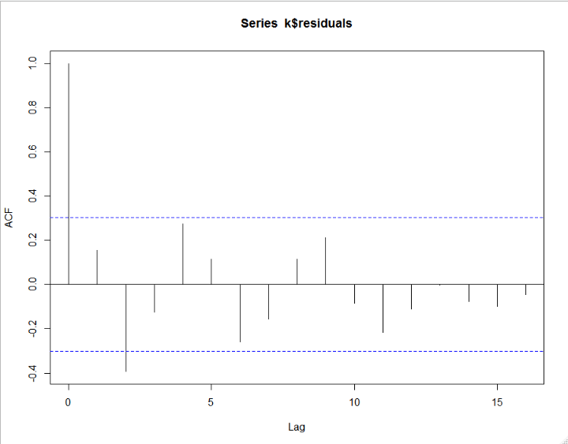

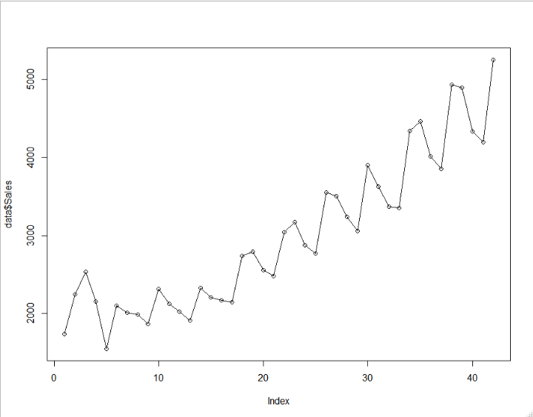

|  | **model** | **RMSE** |
| --- | --- | --- |
|  |  |  |
| **1** | rmse_linear | 620.7862 |
| **2** | rmse_expo | 4238.5334 |
| **3** | rmse_Quad | 458.8969 |
| **4** | rmse_sea_add | 1822.8497 |
| **5** | rmse_Add_sea_Quad | 266.4439 |
| **6** | rmse_multi_sea | 1906.6029 |
| **7** | rmse_multi_add_sea | 309.9950 |

Showing 1 to 7 of 7 entries, 2 total columns

Airlines data set

library(readxl)

#loading the data in excel into the system##

data <- read_excel(file.choose())

View(data)## Month seasonality in the data set##

head(data)

windows()

plot(data$Passengers,type='o')

# So creating 12 dummy variables

X<- data.frame(outer(rep(month.abb,length = 96), month.abb,"==") + 0 )# Creating dummies for 12 months

View(X)

colnames(X)<-month.abb # Assigning month names

View(X)

##combining data to x##

data <- cbind(data,X)

View(data)

colnames(data)

data['t'] <- 1:96

View(data)

data['log_passengers'] <- log(data$Passengers)

View(data)

data['t_squared'] <- data$t*data$t

View(data)

attach(data)

##spliting the data##

train <- data[1:70,]

test <- data[70:96,]

########################### LINEAR MODEL #############################

linear_model<-lm(Passengers~t,data=train)

summary(linear_model)

linear_pred<-data.frame(predict(linear_model,interval='predict',newdata =test))

View(linear_pred)

rmse_linear<-sqrt(mean((test$Passengers-linear_pred$fit)^2,na.rm = T))

rmse_linear # 47.6409

######################### Exponential #################################

expo_model<-lm(log_passengers~t,data=train)

summary(expo_model)

expo_pred<-data.frame(predict(expo_model,interval='predict',newdata=test))

rmse_expo<-sqrt(mean((test$log_passengers-exp(expo_pred$fit))^2,na.rm = T))

rmse_expo # 301.5812

######################### Quadratic ####################################

Quad_model<-lm(Passengers~t+t_squared,data=train)

summary(Quad_model)

Quad_pred<-data.frame(predict(Quad_model,interval='predict',newdata=test))

rmse_Quad<-sqrt(mean((test$Passengers-Quad_pred$fit)^2,na.rm=T))

rmse_Quad # 43.45248

######################### Additive Seasonality #########################

sea_add_model<-lm(Passengers~Jan+Feb+Mar+Apr+May+Jun+Jul+Aug+Sep+Oct+Nov,data=train)

summary(sea_add_model)

sea_add_pred<-data.frame(predict(sea_add_model,newdata=test,interval='predict'))

rmse_sea_add<-sqrt(mean((test$Passengers-sea_add_pred$fit)^2,na.rm = T))

rmse_sea_add # 123.0927

######################## Additive Seasonality with Linear #################

Add_sea_Linear_model<-lm(Passengers~t+Jan+Feb+Mar+Apr+May+Jun+Jul+Aug+Sep+Oct+Nov,data=train)

summary(Add_sea_Linear_model)

Add_sea_Linear_pred<-data.frame(predict(Add_sea_Linear_model,interval='predict',newdata=test))

rmse_Add_sea_Linear<-sqrt(mean((test$Passengers-Add_sea_Linear_pred$fit)^2,na.rm=T))

rmse_Add_sea_Linear #33.87741

######################## Additive Seasonality with Quadratic #################

Add_sea_Quad_model<-lm(Passengers~t+t_squared+Jan+Feb+Mar+Apr+May+Jun+Jul+Aug+Sep+Oct+Nov,data=train)

summary(Add_sea_Quad_model)

Add_sea_Quad_pred<-data.frame(predict(Add_sea_Quad_model,interval='predict',newdata=test))

rmse_Add_sea_Quad<-sqrt(mean((test$Passengers-Add_sea_Quad_pred$fit)^2,na.rm=T))

rmse_Add_sea_Quad # 29.86647

######################## Multiplicative Seasonality #########################

multi_sea_model<-lm(log_passengers~Jan+Feb+Mar+Apr+May+Jun+Jul+Aug+Sep+Oct+Nov,data = train)

summary(multi_sea_model)

multi_sea_pred<-data.frame(predict(multi_sea_model,newdata=test,interval='predict'))

rmse_multi_sea<-sqrt(mean((test$Passengers-exp(multi_sea_pred$fit))^2,na.rm = T))

rmse_multi_sea # 127.7214

######################## Multiplicative Seasonality Linear trend ##########################

multi_add_sea_model<-lm(log_passengers~t+Jan+Feb+Mar+Apr+May+Jun+Jul+Aug+Sep+Oct+Nov,data = train)

summary(multi_add_sea_model)

multi_add_sea_pred<-data.frame(predict(multi_add_sea_model,newdata=test,interval='predict'))

rmse_multi_add_sea<-sqrt(mean((test$Passengers-exp(multi_add_sea_pred$fit))^2,na.rm = T))

rmse_multi_add_sea # 11.64118

# Preparing table on model and it's RMSE values

table_rmse<-data.frame(c("rmse_linear","rmse_expo","rmse_Quad","rmse_sea_add","rmse_Add_sea_Quad","rmse_multi_sea","rmse_multi_add_sea"),c(rmse_linear,rmse_expo,rmse_Quad,rmse_sea_add,rmse_Add_sea_Quad,rmse_multi_sea,rmse_multi_add_sea))

View(table_rmse)

colnames(table_rmse)<-c("model","RMSE")

View(table_rmse)

#Multiplicative Seasonality Linear trend has least RMSE value

new_model <- lm(log_passengers~t+Jan+Feb+Mar+Apr+May+Jun+Jul+Aug+Sep+Oct+Nov,data = data)

# Building Autoregressive model on residuals consider lag-1

resid <- residuals(new_model)

resid[1:10]

windows()

acf(resid,lag.max = 10)

# By principal of parcimony we will consider lag - 1 as we have so

# many significant lags

k <- arima(resid, order=c(1,0,0))

str(k)

View(data.frame(res=resid,newresid=k$residuals))

windows()

acf(k$residuals,lag.max = 15)

pred_res<- predict(arima(k$residuals,order=c(1,0,0)),n.ahead = 12)

str(pred_res)

pred_res$pred

acf(k$residuals)

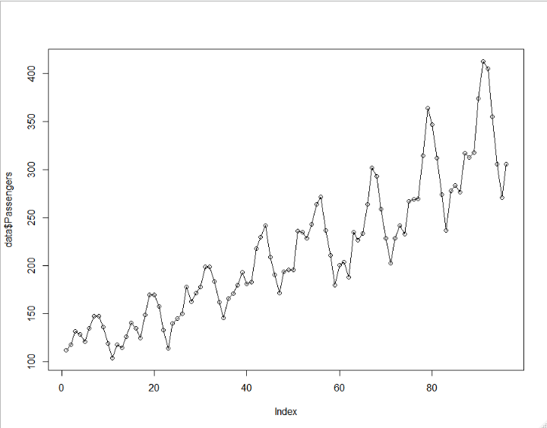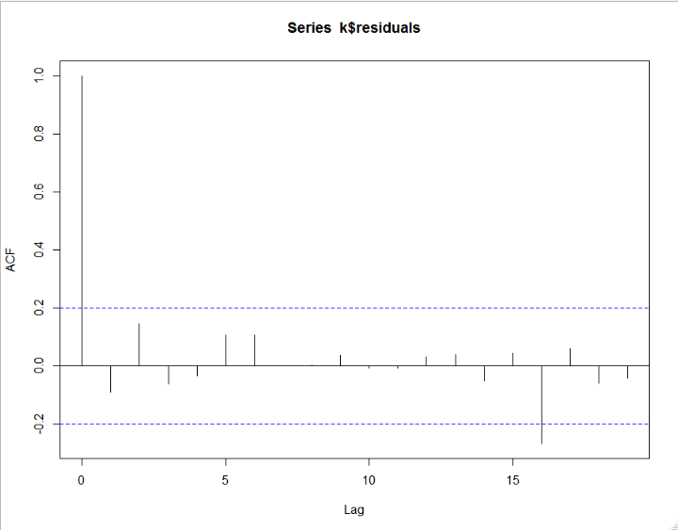

|  | **model** | **RMSE** |
| --- | --- | --- |
|  |  |  |
| **1** | rmse_linear | 47.64090 |
| **2** | rmse_expo | 301.58115 |
| **3** | rmse_Quad | 43.45248 |
| **4** | rmse_sea_add | 123.09267 |
| **5** | rmse_Add_sea_Quad | 29.86647 |
| **6** | rmse_multi_sea | 127.72137 |
| **7** | rmse_multi_add_sea | 11.64118 |

Showing 1 to 7 of 7 entries, 2 total columns